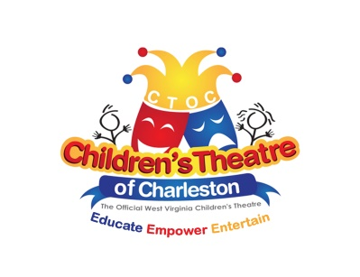
Join us for our 89thseason!!!

Dear Applicant,

On behalf of the Children’s Theatre of Charleston’s Board of Directors, please consider the enclosed materials as our invitation for you to apply for any of the following positions: director, musical director, assistant director/stage manager, set technician, prop master, costumer, lighting technician, choreographer or sound technician for the Children’s Theatre of Charleston’s 2021– 2022 season.

The Children’s Theatre of Charleston, the Official West Virginia Children’s Theatre, is a community theater with a broad following and a rich history. Generations of Charleston’s youth have had the opportunity to try their hand at acting, singing and dancing on stage, thanks to the efforts of Miss Sara Spencer who formed the group in 1932. Children’s Theatre of Charleston envisions a world in which all children experience life changing effects of theatre, including sparking their creativity, boosting their self- confidence and igniting a passion for the arts.

As a community theater group, CTOC relies primarily upon unpaid volunteers for its existence. All production positions at CTOC are hired on a per-show basis with no benefits. Use of union labor has been waived for CTOC at the Charleston Coliseum Little Theater and Clay Center, where our productions are held. Guest directors who are union members typically have obtained waivers to work for CTOC.

Please complete the Application form provided, indicating your interest in each production. Any employee of CTOC must agree to a background check. All applicants must also be willing to
follow all CTOC policies including those for auditions, nepotism, casting, and our guidelines as set out in the job descriptions (please see our website www.ctoc.org). You will need to provide the names and addresses of at least two references. Send the aforementioned and a resume, by email or postmarked no later than March 7, 2021. Due to grant requirements, a resume must be provided for consideration, even if you have worked for us before. Please note the short time frame to get your applications submitted. You will receive an email confirmation upon receipt of your application. Please feel free to include any additional information that would assist the Board in their deliberations.

The Children’s Theatre holds approximately 6-8 weeks of rehearsal for each show. Rehearsals
are held at our workshop located at 115 Spring Street in Charleston. Rehearsals are scheduled weekday evenings from 6:30-8:30, and traditionally on Sunday afternoons from 2:00-5:00. The rehearsal
schedule is at the discretion of the director but due to having children in the cast, we do not allow
rehearsals to be scheduled later than 8:30 on weekdays except for Tech Week. This season will consist of three main stage productions to be held at the Charleston Coliseum & Convention Center Little Theater and/or the Clay Center.

The Board of Directors will make selection of the production staff by the end of March, after considering all applications received by March 7, 2021. The Board will review information
provided by you concerning your experience, availability, success of productions with which you were instrumental, and creative enthusiasm.

If you have any questions regarding this invitation for application, or require additional information, please contact the Children’s Theatre by email at ctocwv@gmail.com.

We look forward to receiving your application.

Sincerely,

Kit Reed
CTOC Board President

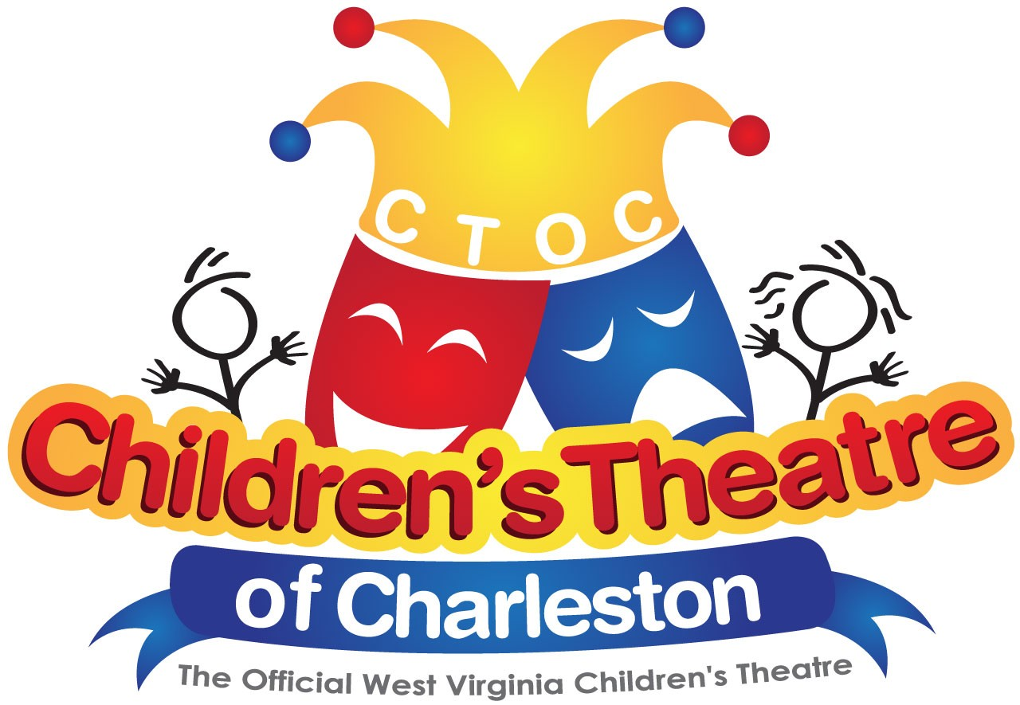

Children’s Theatre of Charleston
2021-2022 Season

The NeverEnding Story
Straight Play
Dramatic Publishing
60 Minutes
Auditions: August 6-7, 2021
Move-in: September 26, 2021
Performances: September 30 & October 1-3, 2021

The Best Christmas Pageant Ever
Musical
Concord Theatricals
60 Minutes
Auditions: October 9-10, 2021
Move-in: December 5, 2021
Performances: December 9-12, 2021

Disney’s Beauty and the Beast Jr.
Musical
MTI
65 Minutes
Auditions: January 8-9, 2022
Move-in: March 27, 2022
Performances: April 1-3, 2022

