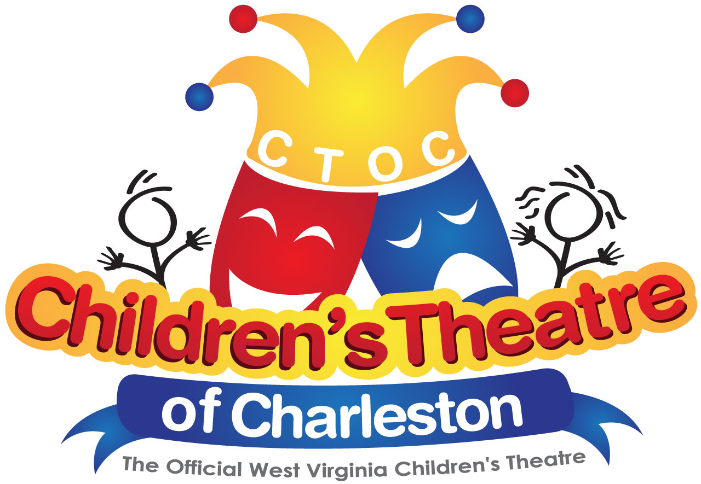

The Children’s Theatre of Charleston, Inc.
The Official West Virginia Children’s Theatre
Post Office Box 11060
Charleston, West Virginia 25339-1060
(304) 741-9099

Children’s Theatre of Charleston
Proudly Presents
Elf the Musical Jr.

Don’t miss the upcoming Children’s Theatre production of Elf the Musical Jr. at the Charleston Civic Center Little Theater on December 6th and December 7th, 2018. Buddy, a young orphan, mistakenly crawls into Santa’s bag of gifts and is transported to the North Pole. The would-be elf is raised, unaware that he is actually a human, until his enormous size and poor toy-making abilities cause him to face the truth. With Santa’s permission, Buddy embarks on a journey to New York City to find his birth father and discover his true identity. Faced with the harsh reality that his father is on the naughty list and that his half-brother doesn’t even believe in Santa, Buddy is determined to win over his new family and help New York remember the true meaning of Christmas.

Elf the Musical Jr. will be performed at the Charleston Civic Center Little Theater on Thursday, December 6th and Friday, December 7th at 9:15 a.m. and 11:00 a.m. (both days).

Admission: Admission is $5.00 per student. One free chaperone ticket is available for every 10 students. Any additional adults will be $12.00.

Additional Adults: Adults (who are not official chaperones from the school) are welcome to attend the school performances, however, tickets will not be sold to them until all schools have been seated. Tickets will be sold if there are extra seats available.

Reservations: Please email LeeAnne Rheinlander at msla25560@yahoo.com to reserve a time. Next, complete the enclosed reservation form and mail it with your deposit. If you have questions, please call LeeAnne Rheinlander at 304-610-5729.

CSOs: Content, Standards and Objectives for Children’s Theatre performances are available on our website: www.ctoc.org.

Bus Information: We will be sending out information for your bus drivers with your confirmation/receipt letter.

CTOC RESERVATION FORM

Name of Show: Elf the Musical Jr.
Date: Thursday, December 6th 9:15 am ________

11:00 am ________
Friday, December 7th 9:15 am _________

11:00 am ________
______________________________________________________________________

Name of School: _______________________________________ Date: ___________

Principal: _________________________ Contact Person: _______________________

School Address: ________________________________________________________

Telephone: ___________________________ Email: ___________________________

- Cost is $5.00 per student
- Children’s Theatre of Charleston chaperone policy: One (1) chaperone will be allowed to attend with every ten (10) students. Complimentary passes will be sent with your reservation confirmation. Any adult arriving at the Charleston Civic Center Little Theater without a pass will be asked to wait until all others are seated. They will be charged the full adult admission price of $12.00 and be seated, if space is available.
- A non-refundable, 20% reservation deposit must be sent to the below address in order to guarantee your reservation. A receipt of deposit will be returned immediately.
. Make checks payable to Children’s Theatre of Charleston. There will be an additional $10.00 charge for any payments made by credit card. We accept credit card payments at the show only if you have the card with you at that time
- Please return this reservation form and deposit to : Children’s Theatre of Charleston
c/o LeeAnne Rheinalnder
P.O. Box 11060
Charleston, WV 25302
______________________________________________________________________

The show will last approximately one hour and 10 minutes. When making reservations, make sure your numbers are correct. The number you put on this form will be enforced at seating time. Chaperones must have their passes or will be charged full admission ($12.00) if seating is available. Enjoy the show!

TEACHER | GRADE LEVEL | # OF STUDENTS | # OF CHAPERONES

