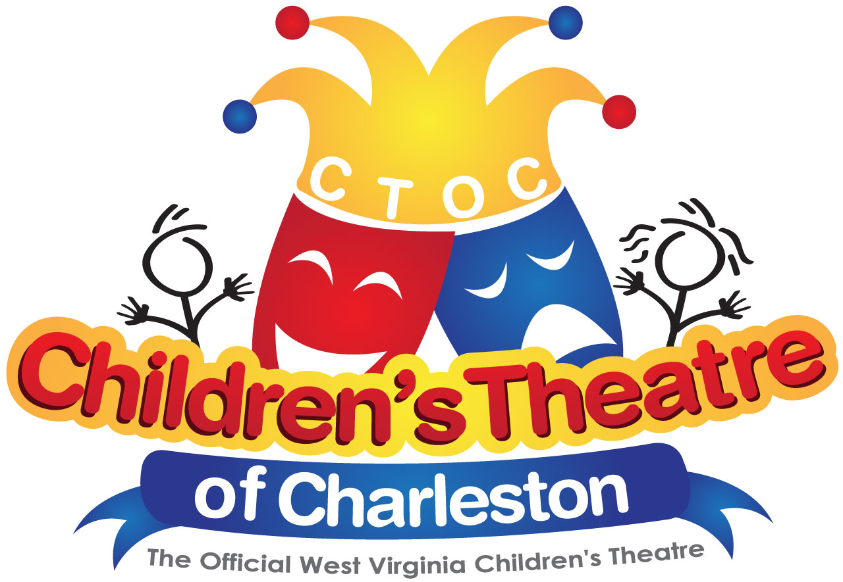

The Children’s Theatre of Charleston, Inc.
The Official West Virginia Children’s Theatre
Post Office Box 11060
Charleston, West Virginia 25339-1060
(304) 741-9099

Children’s Theatre of Charleston
Proudly Presents
Cinderella

Don’t miss the upcoming Children’s Theatre production of Cinderella at the Charleston Civic Center Little Theater on March 23rd and March 24^{h}, 2017. The timeless enchantment of a magical fairy tale is reborn with the Rodgers & Hammerstein hallmarks of originality, charm and elegance.
Originally presented on television in 1957 starring Julie Andrews, Rodgers & Hammerstein's Cinderella was the most widely viewed program in the history of the medium.
As adapted for the stage, with great warmth and more than a touch of hilarity, the hearts of children and adults alike still soar when the slipper fits. This Enchanted Edition is based on the 1997 teleplay.

Cinderella will be performed at the Charleston Civic Center Little Theater on Thursday, March 23rd and Friday, March 24th at 9:15 a.m. and 11:00 a.m. (both days).

Admission: Admission is $5.00 per student. One free chaperone ticket is available for every 10 students. Any additional adults will be $12.00.

Additional Adults: Adults (who are not official chaperones from the school) are welcome to attend the school performances, however, tickets will not be sold to them until all schools have been seated. Tickets will be sold if there are extra seats available.

Reservations: Please email LeeAnne Rheinlander at msla25560@yahoo.com to reserve a time. Next, complete the enclosed reservation form and mail it with your deposit. If you have questions, please call LeeAnne Rheinlander at 304-610-5729.

CSOs: Content, Standards and Objectives for Children’s Theatre performances are available on our website: www.ctoc.org.

CTOC RESERVATION FORM

Name of Show: Cinderella
Date: Thursday, March 23 9:15 am ________

11:00 am ________
Friday, March 24 9:15 am _________

11:00 am ________
______________________________________________________________________

Name of School: _______________________________________ Date: ___________

Principal: _________________________ Contact Person: _______________________

School Address: ________________________________________________________

Telephone: ___________________________ Email: ___________________________

- Cost is $5.00 per student
- Children’s Theatre of Charleston chaperone policy: One (1) chaperone will be allowed to attend with every ten (10) students. Complimentary passes will be sent with your reservation confirmation. Any adult arriving at the Charleston Civic Center Little Theater without a pass will be asked to wait until all others are seated. They will be charged the full adult admission price of $12.00 and be seated, if space is available.
- A non-refundable, 20% reservation deposit must be sent to the below address in order to guarantee your reservation. A receipt of deposit will be returned immediately.
. Make checks payable to Children’s Theatre of Charleston. There will be an additional $10.00 charge for any payments made by credit card. We accept credit card payments at the show only if you have the card with you at that time
- Please return this reservation form and deposit to : Children’s Theatre of Charleston
c/o LeeAnne Rheinalnder
P.O. Box 11060
Charleston, WV 25302
______________________________________________________________________

The show will last approximately one hour and 15 minutes. When making reservations, make sure your numbers are correct. The number you put on this form will be enforced at seating time. Chaperones must have their passes or will be charged full admission ($12.00) if seating is available. Enjoy the show!

TEACHER | GRADE LEVEL | # OF STUDENTS | # OF CHAPERONES

